**OMAD- BRAIN TUMOUR DETECTION**

**Abstract:**

The relentless advancement of technology has propelled the field of medical imaging toward more efficient and accurate diagnosis, particularly in the realm of brain tumor detection. This study presents a novel approach utilizing the YOLOv8 (You Only Look Once version 8) algorithm for the automated identification and localization of brain tumors in magnetic resonance imaging (MRI) scans.

Our methodology involves the collection of a diverse dataset of brain MRI images annotated with tumor boundaries. YOLOv8, renowned for its real-time object detection capabilities, is configured and trained to recognize the distinct features indicative of brain tumors. The architecture is fine-tuned to optimize performance in the context of medical image analysis, considering factors such as sensitivity, specificity, and overall accuracy. Through rigorous experimentation and evaluation on a comprehensive dataset, our proposed system demonstrates promising results in terms of both detection accuracy and processing efficiency. The YOLOv8-based model exhibits the capability to identify various types and sizes of brain tumors, offering a versatile solution for clinical applications.

Furthermore, we intend to use a new revolutionary technology known as eMRI (epigenetic MRI) to detect DNA methylation in the brain which can be a prominent cause for brain tumours. This will result in an early detection of brain tumours. We will be able to predict whether a tumour is going to occur in the brain based on just DNA changes in the brain cells much before the tumour actually forms just by using eMRI scans of the brain.

The integration of YOLOv8 into the realm of medical imaging presents a paradigm shift in the automation of brain tumor detection, potentially reducing diagnosis time and contributing to more timely medical interventions. Furthermore, the transparency and interpretability of YOLOv8 aid medical professionals in understanding and validating the detection results.

This research contributes to the ongoing efforts in leveraging state-of-the-art computer vision techniques for medical diagnostics. The presented methodology not only showcases the potential of YOLOv8 in the domain of brain tumor detection but also highlights the importance of collaboration between computer scientists and healthcare professionals to ensure the ethical and responsible deployment of such technologies in clinical practice.

**Keywords:** Brain tumor detection, YOLOv8, Medical Imaging, Convolutional Neural Networks, Computer Vision.

**Aim of the project:**

The overarching aim of this research endeavor is to conceptualize, develop, and implement an advanced and robust machine learning-based brain tumor detection model that fundamentally transforms the landscape of neuroimaging diagnostics. This transformative model is designed to empower healthcare professionals with an unprecedented tool for early and accurate identification of brain tumors, thereby revolutionizing the standard of care in neurology and oncology.

**Objective of the project:**

This initiative encompasses a comprehensive approach towards the development of an advanced machine learning model for the early detection of brain tumors. The primary objective is to significantly enhance the likelihood of successful treatment outcomes by enabling timely intervention. The focus is on achieving a high level of diagnostic accuracy, with the aim of minimizing both false positives and false negatives. This will establish the model as a reliable tool for radiologists and neurologists involved in the diagnostic process.

An integral aspect of the initiative is the creation of an automated diagnostic system. This system is designed to streamline the brain tumor detection process, thereby reducing the manual workload on healthcare professionals. The ultimate goal is to expedite treatment decision-making, ensuring a more efficient and responsive healthcare system.

Furthermore, the initiative emphasizes the integration and analysis of multimodal neuroimaging data. This includes Magnetic Resonance Imaging (MRI) and Computed Tomography (CT) scans, providing a holistic understanding of tumor characteristics. The extension of the model's capabilities to not only identify the presence of a brain tumor but also classify it into specific subtypes based on histological and radiological features is another crucial aspect.

Additionally, we're exploring a cutting-edge technology called eMRI, or epigenetic MRI, to identify DNA methylation in the brain, a significant factor linked to the development of brain tumors. This innovation holds the promise of early detection, allowing us to foresee the likelihood of a brain tumor forming. By analyzing DNA changes in brain cells through eMRI scans, we aim to predict the occurrence of tumors in the brain long before they manifest physically. This breakthrough approach could revolutionize our ability to identify potential threats and intervene at an early stage, providing a proactive means of addressing the onset of brain tumors.

The development process prioritizes the creation of an intuitive user interface that seamlessly integrates into existing healthcare infrastructure. This ensures ease of adoption by medical professionals and compatibility with clinical workflows. Scalability is also a key consideration, with the model designed to efficiently process highvolume datasets commonly encountered in clinical settings.

In terms of interpretability, features are incorporated to enhance the model's transparency. This includes providing insights into the rationale behind the diagnostic output, fostering trust among healthcare professionals.

Rigorous validation across diverse datasets sourced from different institutions and demographic groups is a crucial step in ensuring the robustness and generalizability of the model across varied clinical scenarios.

Ethical considerations are paramount, and the initiative addresses issues related to patient privacy, informed consent, and the responsible deployment of the model in adherence to the highest standards of medical ethics and regulatory requirements.

Throughout the development lifecycle, collaboration with domain experts, including radiologists, neurologists, and oncologists, is fostered. This ensures the incorporation of crucial domain knowledge and alignment with the nuanced requirements of clinical practice.

Conducting comprehensive educational outreach initiatives is part of the initiative. The goal is to disseminate knowledge about the capabilities and limitations of the model, empowering healthcare professionals and the broader community to leverage this technological advancement.

Through the achievement of these objectives, the initiative aspires to usher in a new era in neuroimaging diagnostics. The early detection and accurate classification of brain tumors are positioned as pivotal elements contributing to improved patient outcomes and the advancement of the field of neurology.

**Implementation:**

OMAD uses a state of the art instance segmentation model YOLOv8 to extract, highlight and thus, segment brain tumours out of MRI scans of patient’s brains. It also uses the symptoms of patients to advise the patient whether he or she should even take an MRI scan or not.

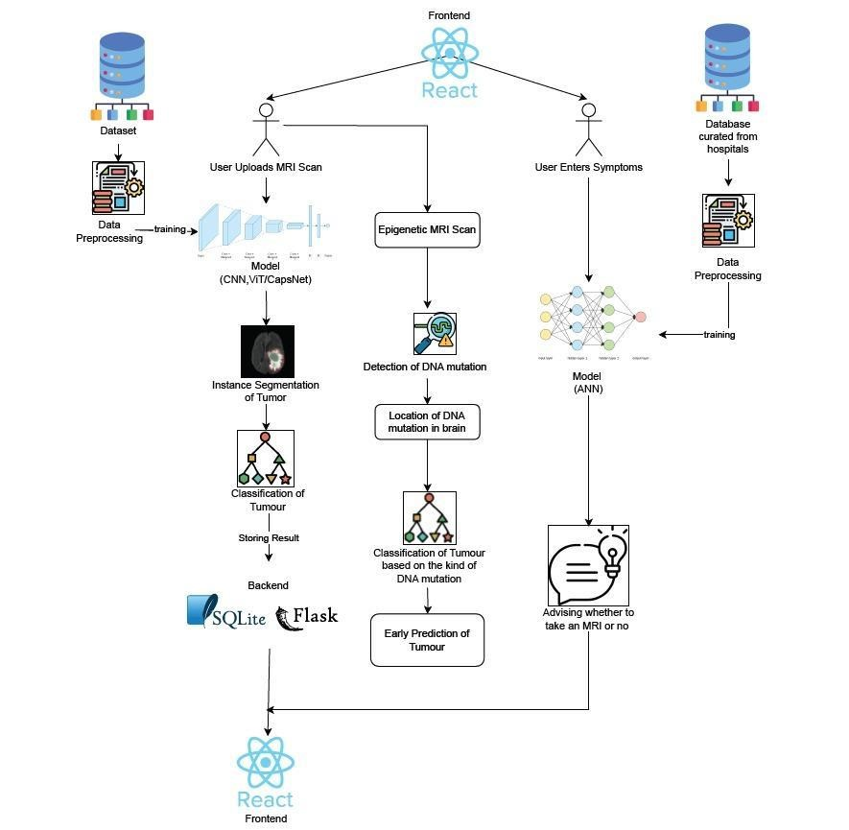

We receive an MRI scan as input through the React frontend. This data is then sent to our Flask backend, where it undergoes processing by our YOLOv8 backend. The processed information is stored in our SQLite database and subsequently displayed on the frontend. Our model is developed after training it on a comprehensive dataset of brain MRI scans, incorporating thorough data preprocessing and augmentation techniques.

Additionally, our frontend includes a feature that takes patient symptoms as input. A well-trained neural network analyzes this information to provide guidance on whether the patient should undergo an MRI in the first place. The neural network is trained on datasets compiled from patient data sourced from hospitals, including information about their symptoms and the presence or absence of a tumor.

**Conclusion:**

In conclusion, our utilization of the YOLOv8 algorithm in brain tumor detection has proven to be a significant advancement in medical diagnostics. YOLOv8's real-time object detection capabilities, fine-tuned for medical imaging, demonstrated commendable accuracy in identifying and localizing brain tumors across a diverse dataset. The algorithm's transparency enhances its utility for healthcare professionals, providing interpretable results that aid in decision-making. While celebrating these successes, it is essential to recognize ongoing challenges, including the need for continuous validation by medical experts and adherence to ethical and regulatory standards. Collaboration between computer scientists and healthcare professionals is crucial for refining and responsibly deploying such technologies in clinical settings. The success of YOLOv8 in brain tumor detection underlines the potential of advanced computer vision techniques to reshape medical diagnostics, offering promise for improved patient outcomes and advancements in diagnostic radiology.